  COURSE CODE/TITLE: | CPE-010 DATA  STRUCTURE AND  ALGORITHM
  DATE PERFORMED: | 7/13/26
  NAME: | PEÑAFLORIDA,WRIO CARLO M.
  SECTION: | CPE21S4
  DATE SUBMITTED: | 7/14/26
  INSTRUCTOR: | ENGR. JIMLORD QUEJADO

Hands-on Activity 1.1 Basic C++ Programming

1. PROCEDURE OUTPUT
First I make a folder and then open the folder in vscode, create source files, type in the codes that is needed for task 1 and 2. Then debugging and run the program.The exe file will pop up if you compile your file.

2. ANSWERS TO SUPPLEMENTAL ACTIVITY
The supplementary activities are meant to gauge your ability in using C++. The problems below range from
easy to intermediate to advanced problems. Note your difficulties after answering the problems below.
1. Create a C++ program to swap the two numbers in different variables.
2. Create a C++ program that has a function to convert temperature in Kelvin to Fahrenheit.
3. Create a C++ program that has a function that will calculate the distance between two points.
4. Modify the code given in ILO B and add the following functions:
a. A function to compute for the area of a triangle
b. A function to compute for the perimeter of a triangle
c. A function that determines whether the triangle is acute-angled, obtuse-angled or ‘others

Output
Sections Answer
Header File Declaration Section #include <iostream>
Global Declaration Section (none — this program has no global variables)
Class Declaration and
Method Definition Section class Triangle {
private:
double totalAngle, angleA, angleB, angleC;
public:
Triangle(double A, double B, double C);
void setAngles(double A, double B, double C);
const bool validateTriangle();
};

Main Function int main() {
//driver code
Triangle set1(40, 30, 110);
if (set1.validateTriangle()) {
std::cout << "The shape is a valid triangle.\n";
} else {
std::cout << "The shape is NOT a valid triangle.\n";
}
return 0;
}

Method Definition Triangle::Triangle(double A, double B, double C) {
angleA = A; angleB = B; angleC = C;
totalAngle = A+B+C;
}
void Triangle::setAngles(double A, double B, double C) {
angleA = A; angleB = B; angleC = C;
totalAngle = A+B+C;
}
const bool Triangle::validateTriangle() {
return (totalAngle <= 180);
}

Table 1-1. C++ Structure Code for Answer
// ===== 1. Header File Declaration Section =====
#include <iostream>

// ===== 2. Global Declaration Section =====
// (none needed for this program)

// ===== 3. Class Declaration and Method Definition Section =====
class Triangle {
private:
double totalAngle, angleA, angleB, angleC;

public:
Triangle(double A, double B, double C);
void setAngles(double A, double B, double C);
const bool validateTriangle();
};

// ===== 4. Main Function =====
int main() {
// driver code
Triangle set1(40, 30, 110);
if (set1.validateTriangle()) {
std::cout << "The shape is a valid triangle.\n";
} else {
std::cout << "The shape is NOT a valid triangle.\n";
}

return 0;
}

// ===== 5. Method Definition =====
Triangle::Triangle(double A, double B, double C) {
angleA = A;
angleB = B;
angleC = C;
totalAngle = A + B + C;
}

void Triangle::setAngles(double A, double B, double C) {
angleA = A;
angleB = B;
angleC = C;
totalAngle = A + B + C;
}

const bool Triangle::validateTriangle() {
return (totalAngle <= 180);
}

Table 1-2. ILO B output observations and comments.
The program created a Triangle object named set1 with angles 40°, 30°, and 110°. The constructor automatically calculated totalAngle as the sum of these three values (180°). When validateTriangle() was called, it checked whether totalAngle <= 180, which returned true since the sum was exactly 180°. This confirmed the shape satisfies the basic geometric rule that a triangle's interior angles must add up to 180° or less in this program's validation logic, so the output correctly displayed "The shape is a valid triangle." This demonstrates that the class's private variables, constructor, and validation method all worked together correctly as designed.

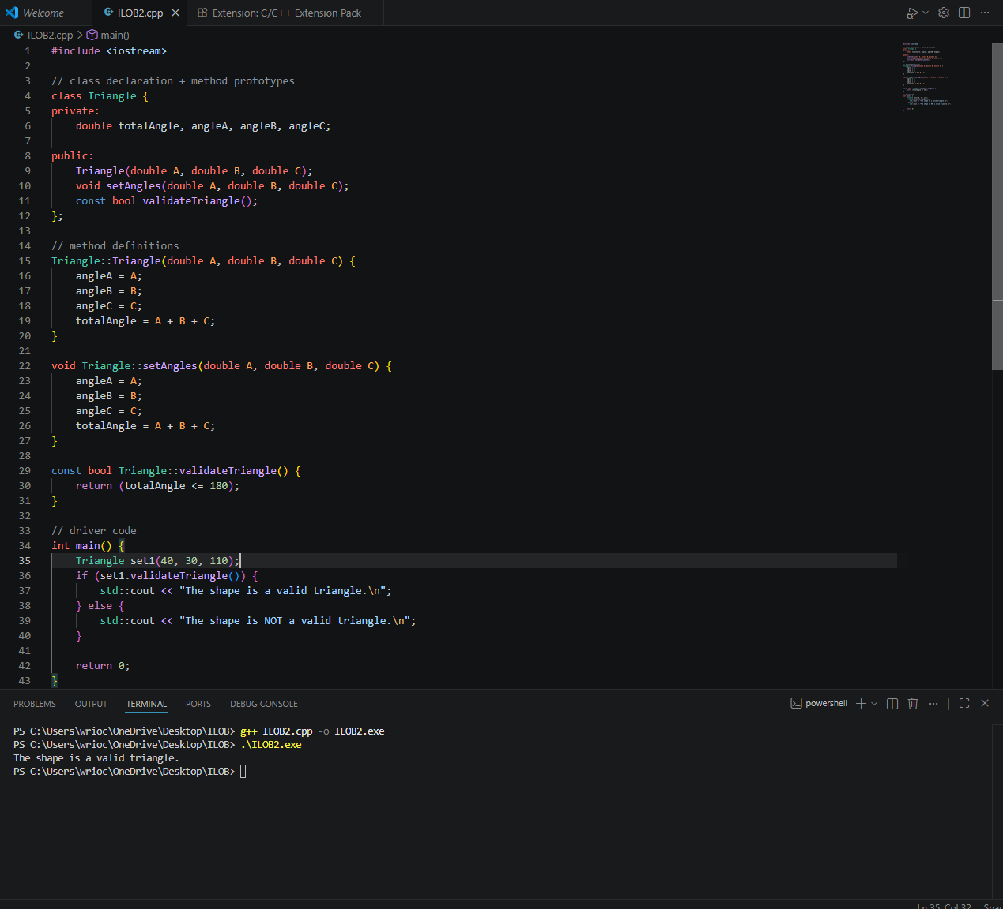
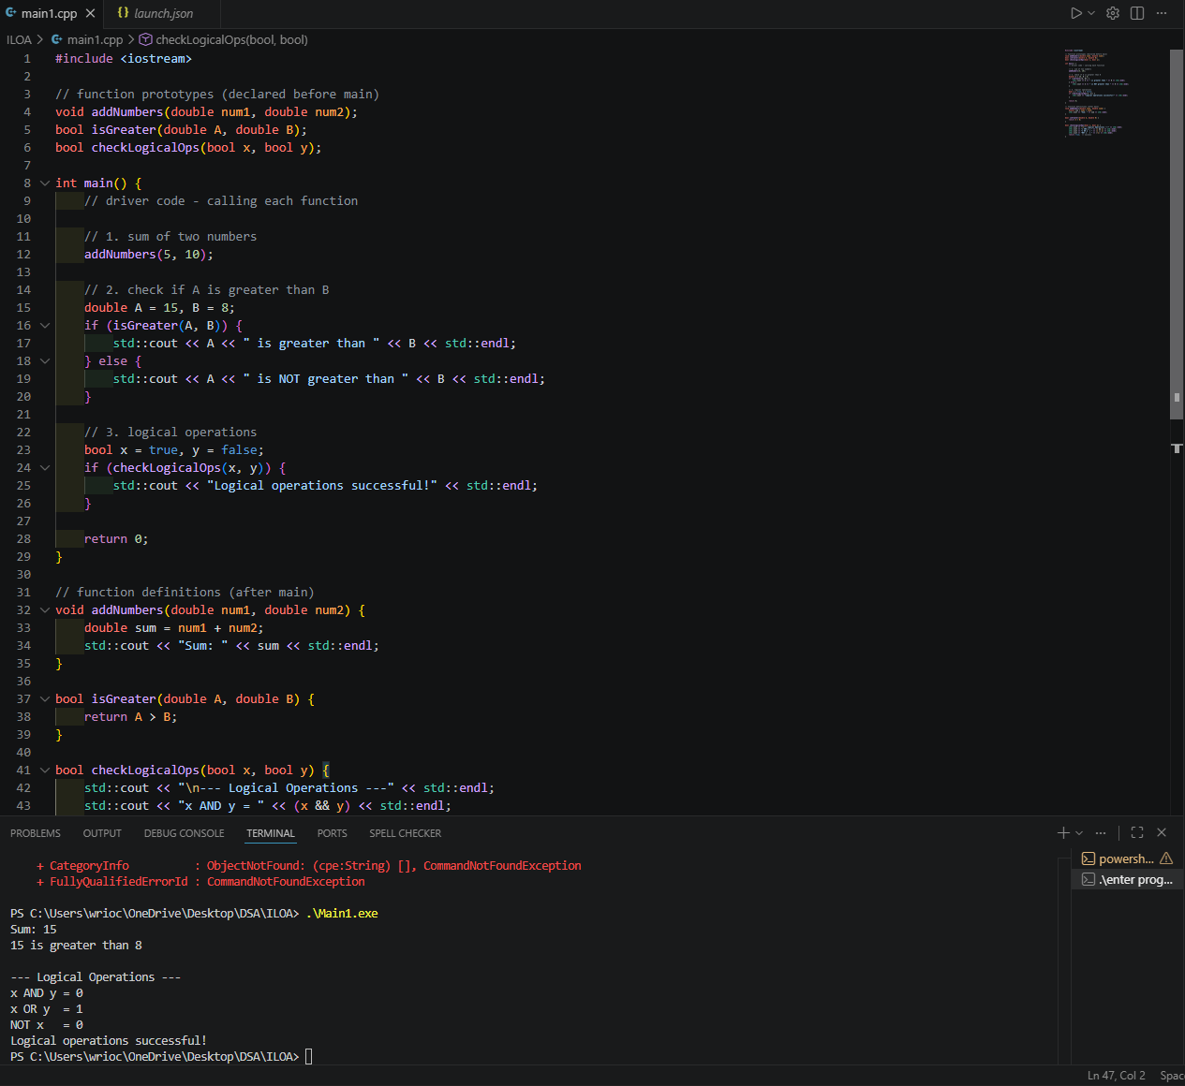

CONCLUSION
This activity reinforced the basic structure of a C++ program — header files, function/class prototypes, and method definitions separated from the main function. I learned how a function prototype allows a function to be declared before main() and defined afterward, keeping the code organized and readable. I also learned how classes work in C++: separating private data members (like angleA, angleB, angleC) from public methods, and how a constructor initializes an object's values as soon as it's created.

3. ARTIFICIAL INTELLIGENCE (AI) USE DISCLOSURE STATEMENT
I hereby declare that artificial intelligence (AI) tools were used, if applicable, in the preparation of this academic work. The following indicates the nature and extent of AI assistance:

Tools Used: Claude

Examples: ChatGPT, Microsoft Copilot, Grammarly, QuillBot, etc.

For general questions like installing the c++ extension and how to set it up on my
Purpose of Use: laptop

Examples: grammar correction, idea generation, formatting, summarization, code assistance, explanation of concepts, etc.

Only help me to install the c++ extensions and missing files that is needed for this
Extent of Use: task to run on my vscode

Explain how AI was used and confirm that it did not replace original thinking, analysis, authorship, or completion of the required work.

By submitting this activity, I affirm that my use of AI complies with T.I.P.’s AI usage policy and does not exceed the permitted limits for similarity, automated content generation, or academic assistance.

I understand that any false, incomplete, or misleading disclosure may be subject to investigation in accordance with due process and may result in sanctions for violation of existing T.I.P. policies.

Lab activities, templates, and related instructional materials shall not be reuploaded, reproduced, distributed, or shared with external organizations or third parties without the prior express written permission of the Technological Institute of the Philippines.

